Task 2

to get vale for k1, k2, and k3 I preform a quadradic regression on the provided data but instead of using u& t I used 1/u and t so I had could find the k values that match the given equation.

The script a6task2 utilizes two list of same size array that need to be entered into the script before running.

When running the script converts u 🡪 1/u to match the initial function and used a cubic solver to find the roots.

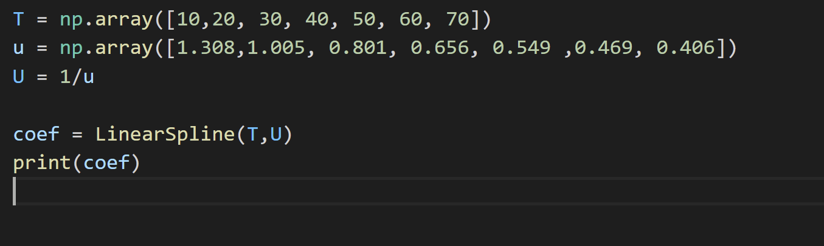

K1 = 5.48097702e-01

K2 = 2.04578790e-02

K3 = 9.88738933e-05

